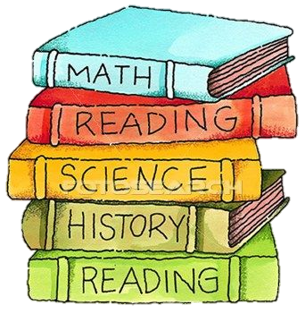

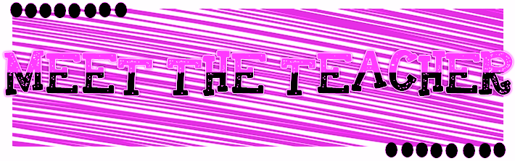
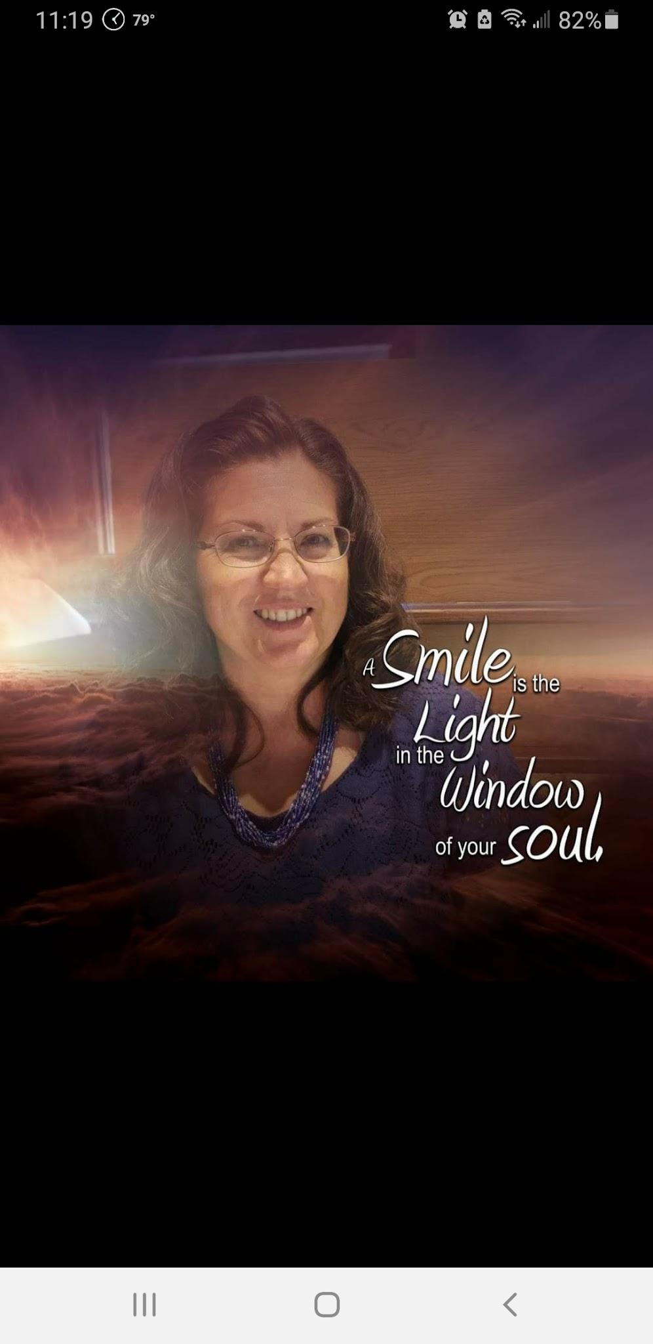

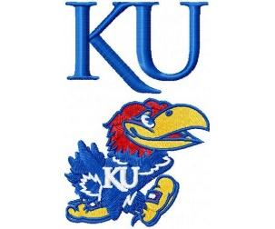


Welcome Back!
I was born in Winfield, Kansas. I have lived in Douglas, Hutchinson, Salina, Kansas City, El Dorado, Wichita, and Towanda, Kansas. I attended Butler County College and Emporia State University. My degrees include Elementary Education and a minor in Music. I also hold a master’s degree in Special Education. My favorite hobbies are gardening, playing the piano, and china painting.

My Favorites…
Food: Italian, Mexican, Oriental

Movie: Sleepless in
Settle and You’ve Got Mail

Book Author: Debbie Macomber

Color: Pink

Drink: Starbucks Coffee/Pepsi

Sports Team: KU Basketball

Hobby: Gardening

Subject: Music/Art

Store: Hobby Lobby

Candy: Heath Bar
Restaurant: Bonefish Grill
Email: smccoy@stjudewichita.org
School Phone: (316) 838-0800
Please feel free to stop by our classroom as well!
Contact Information…
Mrs. McCoy

About me…
Hello everyone! I am Mrs. McCoy and I will be the 3rd grade homeroom teacher. I will also be the 3rd grade religion teacher as well as the Science and Social Studies teacher for grades 3-5. I am so excited to welcome all students back after the summer break. I am excited to be working with the students here at St. Jude Catholic School and am so ready to see their smiles every day. Mr. McCall, Mr. Zimmerman, and I look forward to teaming up and creating a safe, positive, and successful learning culture for your child here at St. Jude Catholic School. We are glad you are part of the St. Jude family!

